- captured during the JIV. (see pictures below)
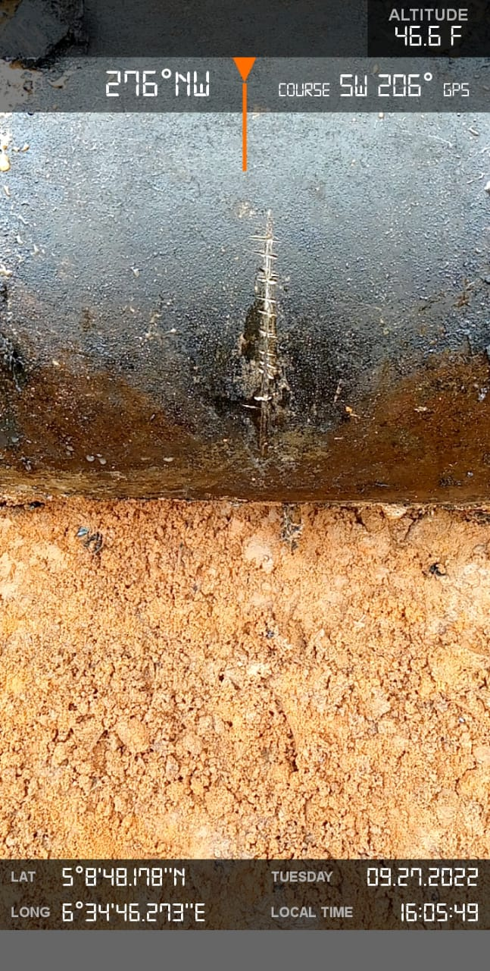
Spill point indicated by an arrow
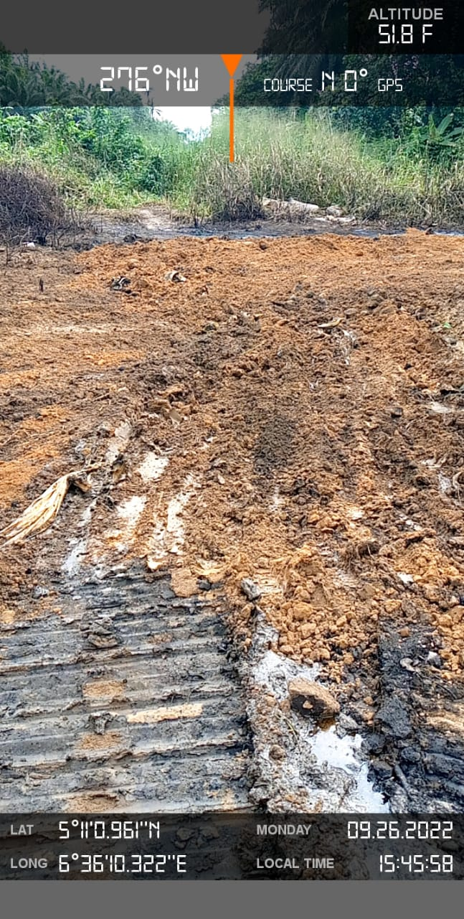
Area impacted by spill

